

**Faculty of Engineering & Technology Electrical & Computer Engineering Department**

**Communication Lab - ENEE4113**

**Experiment 4: Frequency Modulation**

**Prelab #3**

**Student Name**: Maha Maher Mali

**Student ID**: 1200746

**Instructor**: Dr. Ashraf Al_Rimawi

**Teacher Assistant**: Eng. Mohammed Battat

**Section**: 4

**Date**: 7-8-2023

Contents

Software Prelab (Simulink MATLAB) 5

Extract the message signal m(t) from s(t) 5

Plot 5 cycle from Message signal m(t) and s(t) 6

Block Diagram 6

Message Signal 7

Modulated signal s(t) 8

Differentiate s(t) with respect to t and plot ds(t)/dt 10

By Hand Solution 10

Using Simulink 11

Apply ds(t)/dt to an ideal envelope detector 13

By Hand Solution 13

Extract message signal by using phase-locked loop (PLL) 14

Block Diagram 14

In time Domine 14

In frequency Domine 15

Extract the message signal by using the envelop detector 16

Block Diagram 16

In Time Domine 16

In frequency Domine 17

**Table of Figures**

Figure 1:Stepes to Extract the message signal m(t) from s(t) 5

Figure 2:Message Signal 6

Figure 3: FM Modulation Block Diagram 6

Figure 4: Message Signal in Time domine 7

Figure 5: Frequency Domine 7

Figure 6: Modulated signal In Time Domine 8

Figure 7: Modulated signal in frequency Domine 9

Figure 8: Differentiate s(t) 10

Figure 9: Block Diagram to Differentiate s(t) 11

Figure 10: Differentiate s(t) in time domine 11

Figure 11: Differentiate s(t) in frequency domine 12

Figure 12: Apply ds(t)/dt to an ideal envelope detector 13

Figure 13:FM Demodulation by PLL Block Diagram 14

Figure 14: Demodulated signal in time domine 14

Figure 15: Demodulated signal in frequency domine 15

Figure 16::FM Demodulation by using the envelop detector Block Diagram 16

Figure 17: Demodulated signal in time domine 16

Figure 18: Demodulated signal in time domine 17

# Software Prelab (Simulink MATLAB)

## Extract the message signal m(t) from s(t)

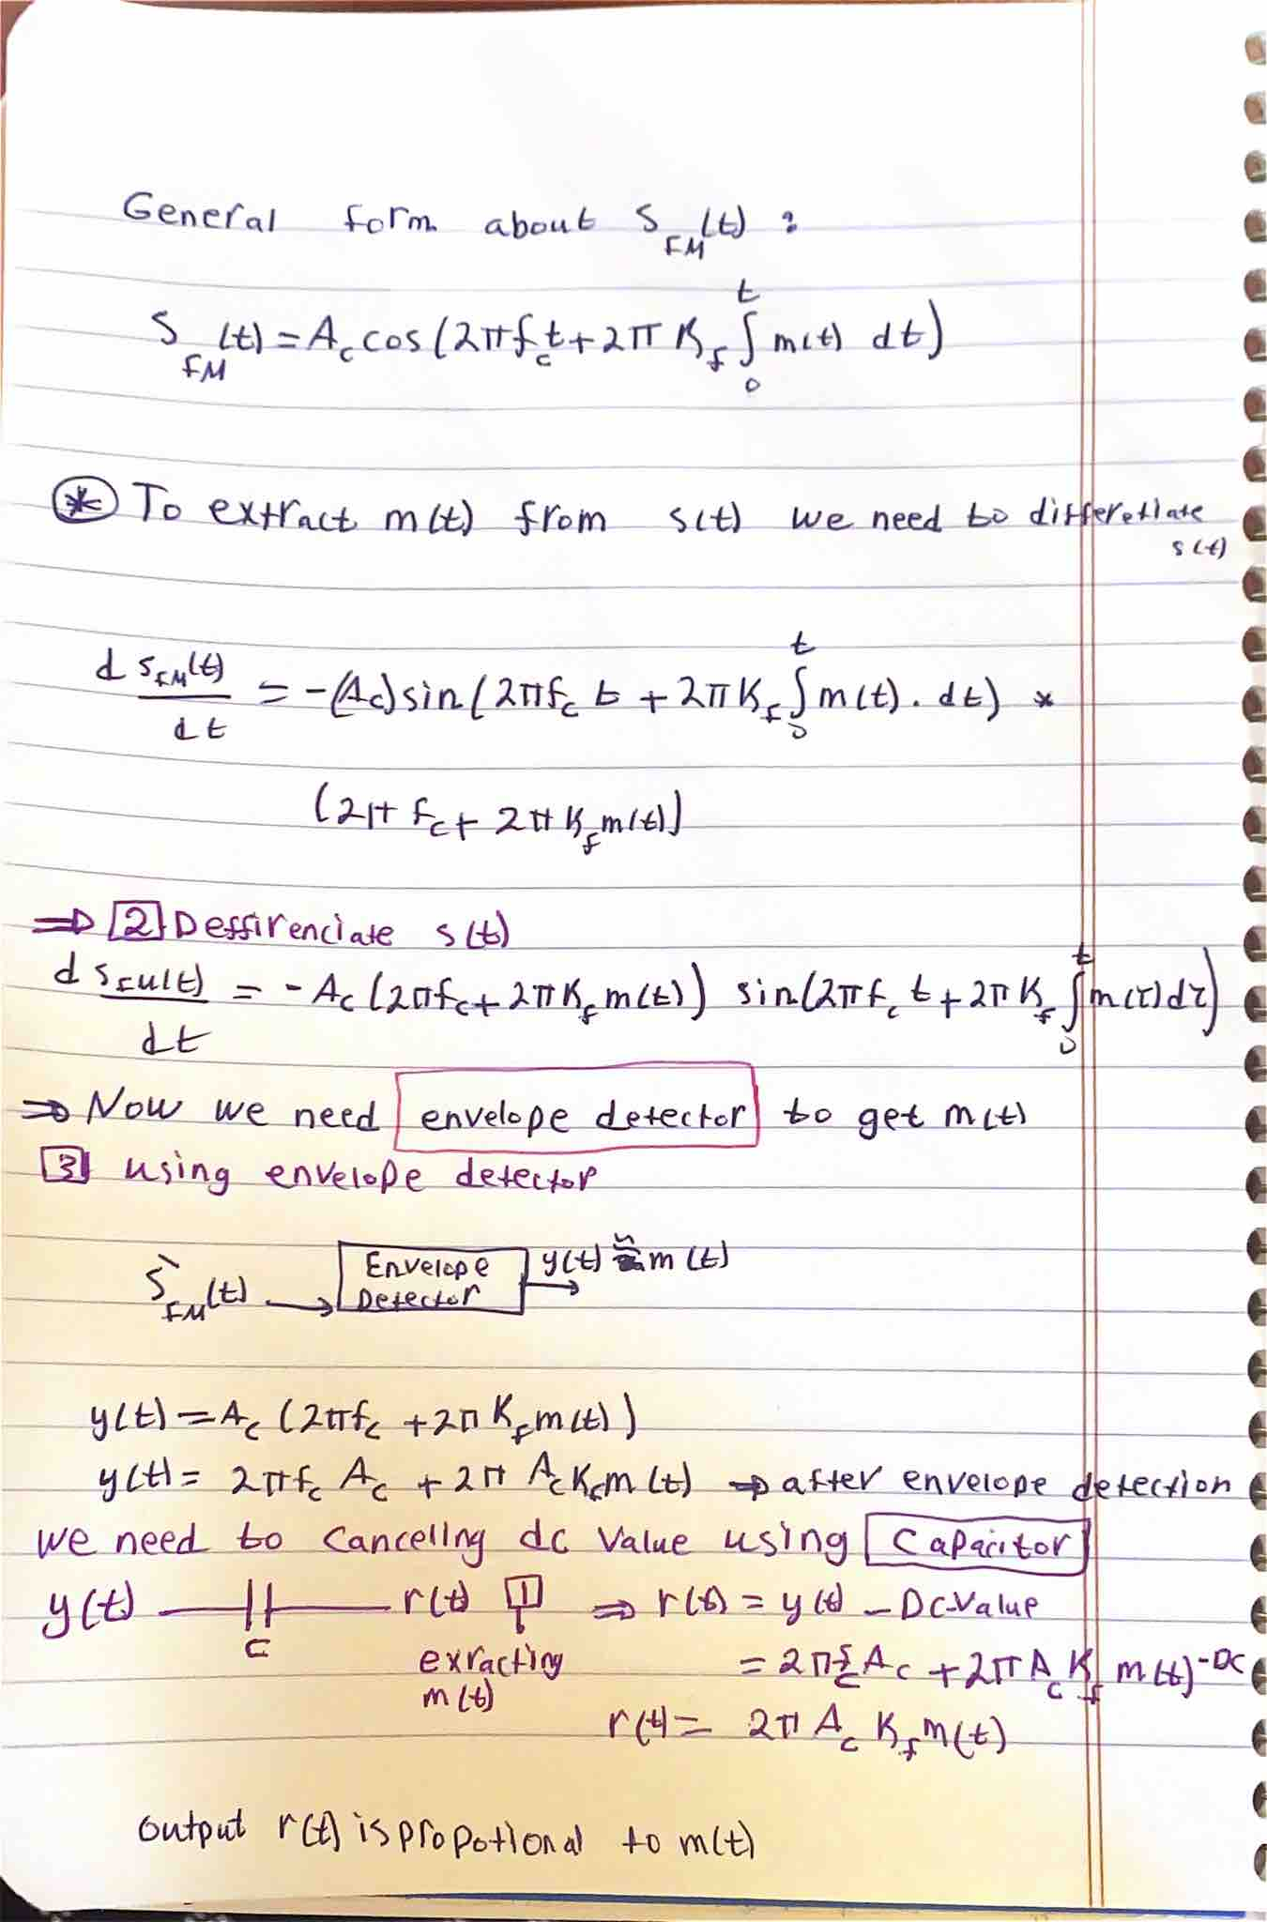

Figure :Stepes to Extract the message signal m(t) from s(t)

The figure shows the calculation to find the message signal:

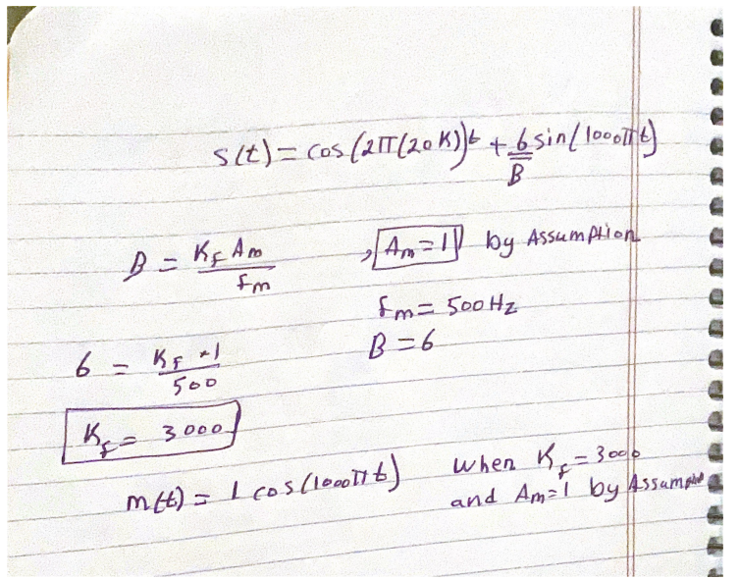

Figure 2:Message Signal

## Plot 5 cycle from Message signal m(t) and s(t)

### Block Diagram

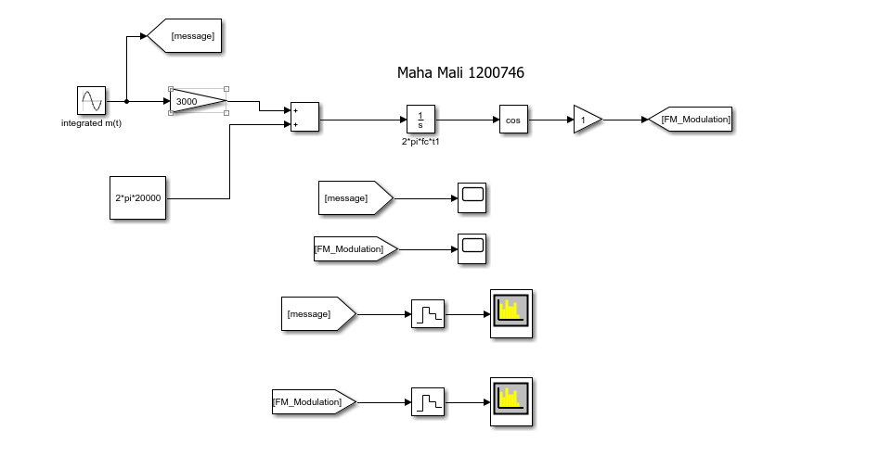

Figure 3: FM Modulation Block Diagram

### Message Signal

#### Time Domine

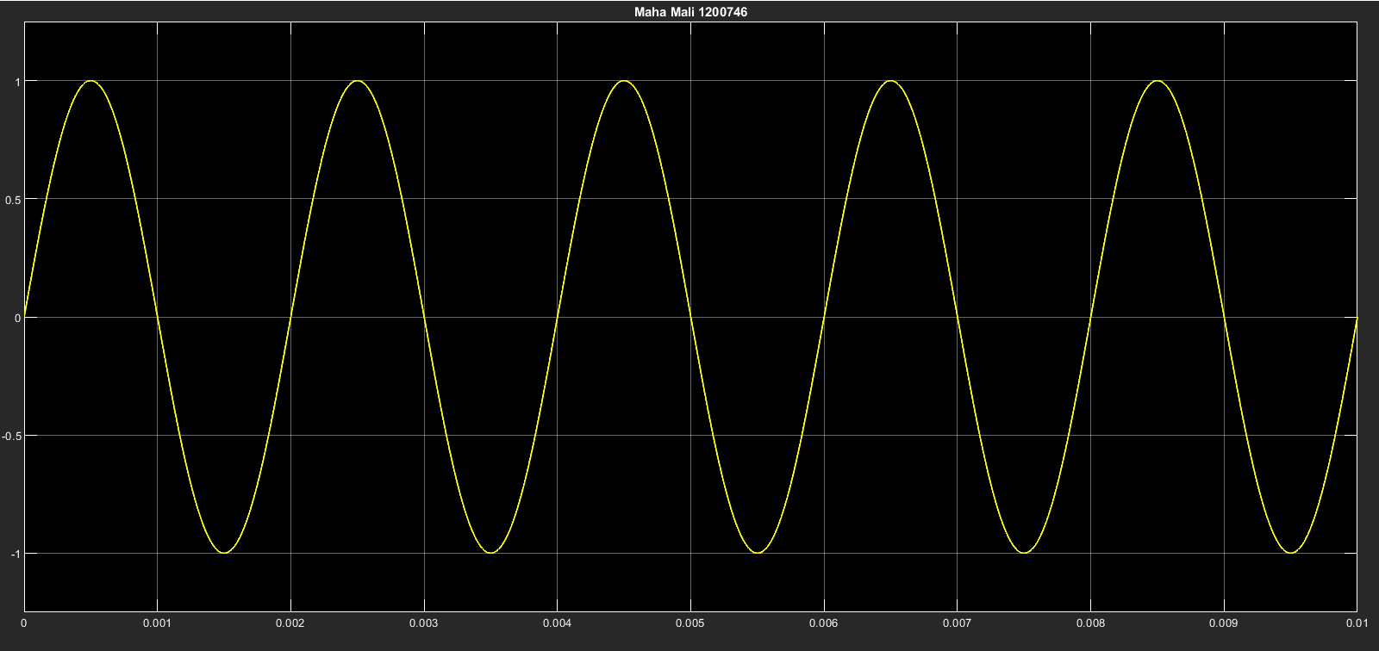

Figure 4: Message Signal in Time domine

From this graph we notice that we got the m(t) that we calculate it by hand with amplitude 1 .

#### Frequency Domine

Figure 5: Frequency Domine

The figure 5 show that we have two delta one at 500 Hz, and another on -500 Hz , according the equation for m(f).

### Modulated signal s(t)

#### Time Domine

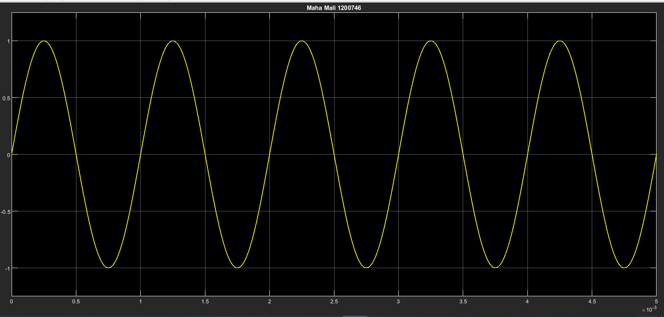

Figure 6: Modulated signal In Time Domine

#### Frequency Domine

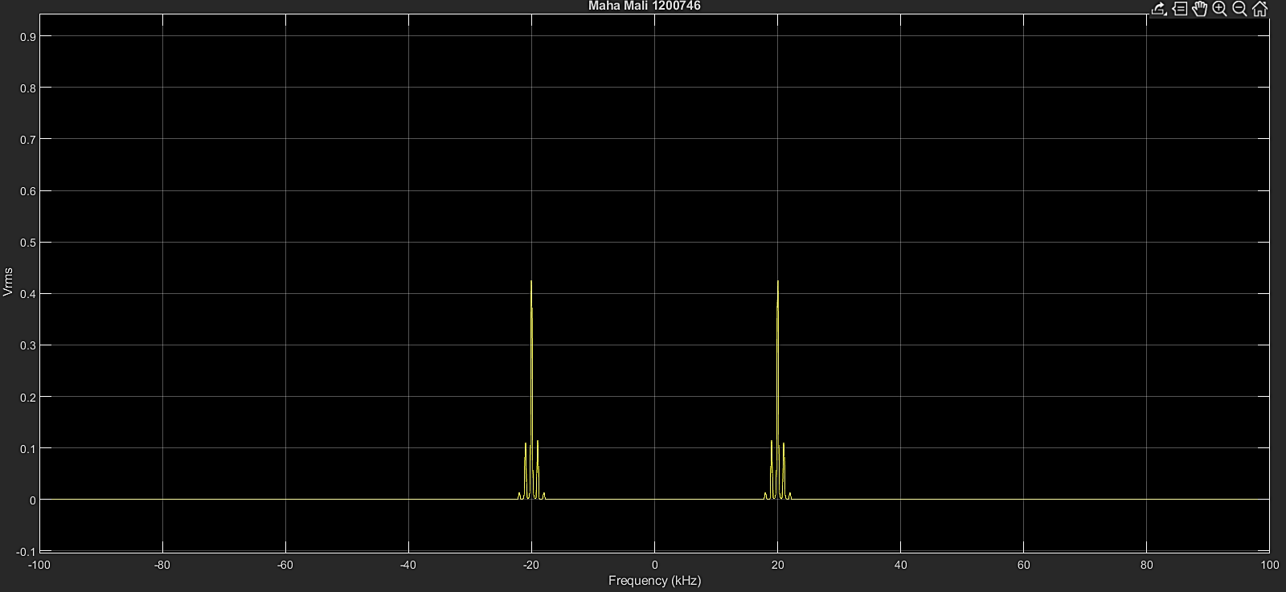

Figure 7: Modulated signal in frequency Domine

## Differentiate s(t) with respect to t and plot ds(t)/dt

### By Hand Solution



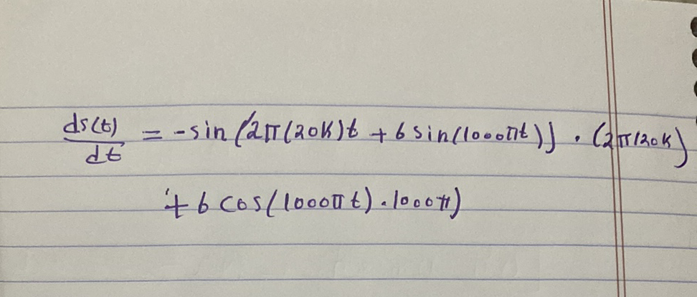

Figure 8: Differentiate s(t)

The differentiation of function s(t) unveils a transition from a rapidly changing frequency modulation (FM) waveform to a slower amplitude modulation (AM) pattern. The original FM waveform, characterized by a 20,000 Hz carrier frequency and modulation, evolves into the derivative waveform ds(t)/dt. This shift from FM to AM-like behavior is a result of differentiation's emphasis on higher frequencies and its impact on reshaping signal traits

### Using Simulink

#### Block Diagram

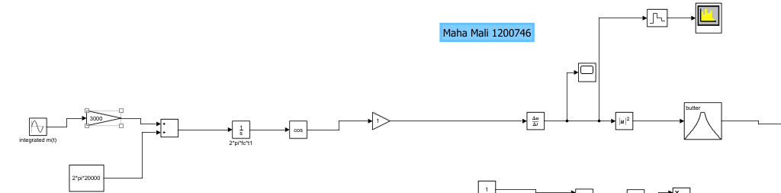

Figure 9: Block Diagram to Differentiate s(t)

#### Time domine

Figure 10: Differentiate s(t) in time domine

##### Frequency domine

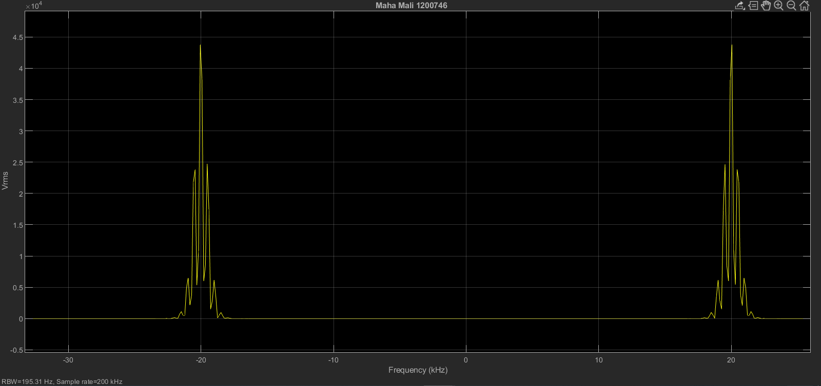

Figure 11: Differentiate s(t) in frequency domine

## Apply ds(t)/dt to an ideal envelope detector

### By Hand Solution



Figure 12: Apply ds(t)/dt to an ideal envelope detector

## Extract message signal by using phase-locked loop (PLL)

### Block Diagram

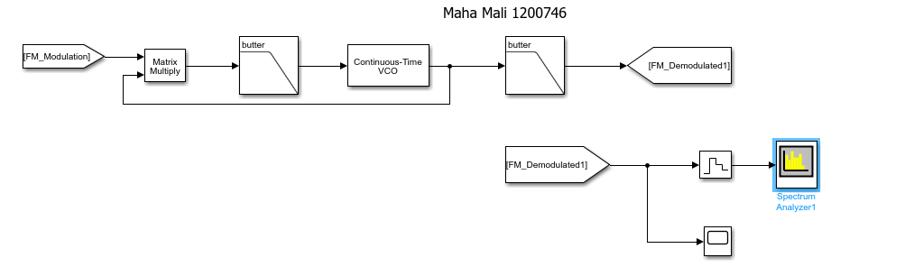

Figure 13:FM Demodulation by PLL Block Diagram

### In time Domine

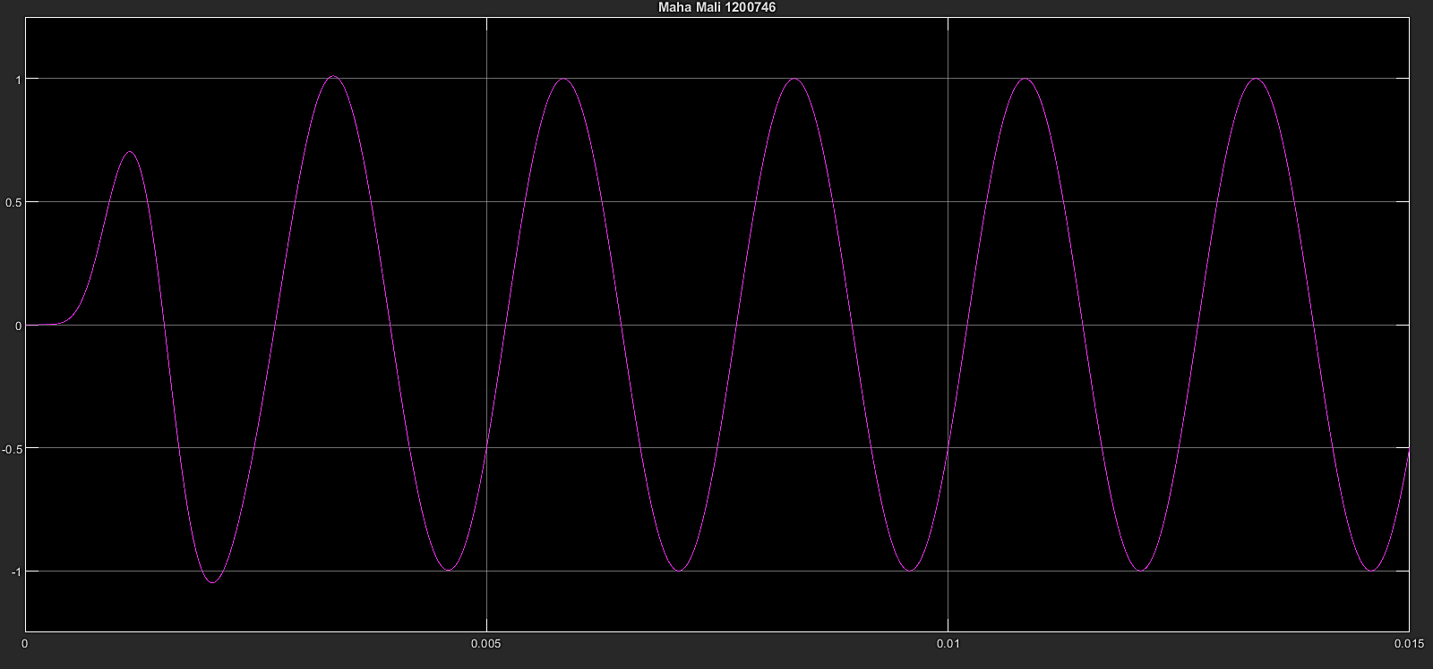

Figure 14: Demodulated signal in time domine

The figure 14 shows the amplitude of the demodulated signal has the same amplitude of message signal which is 1.

### In frequency Domine

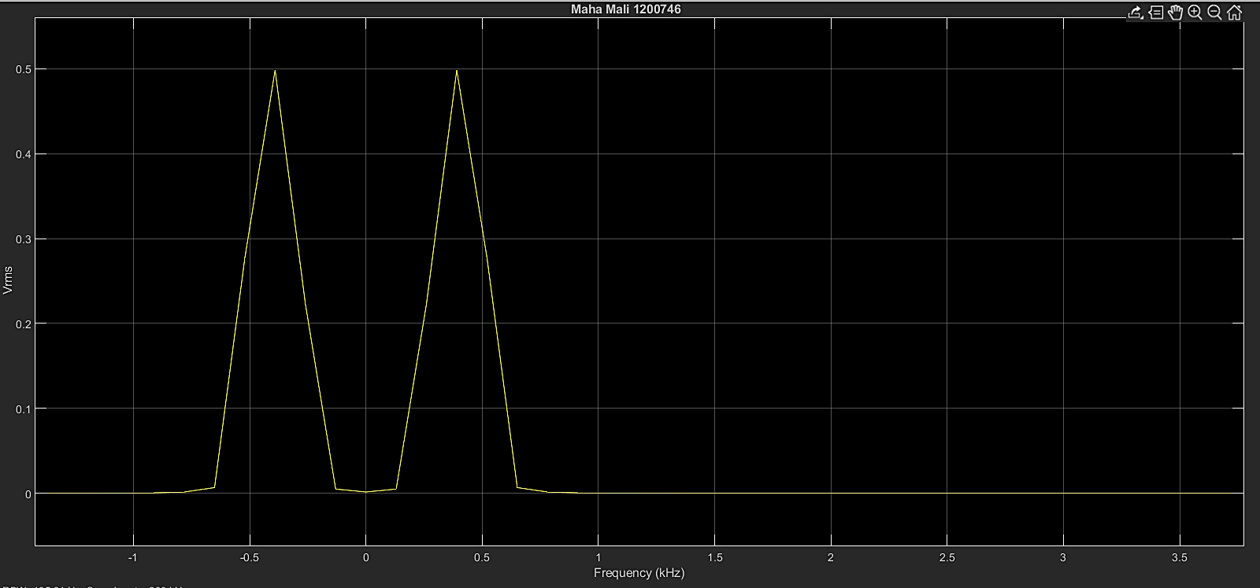

Figure 15: Demodulated signal in frequency domine

The figure show that the demodulated signal has the same frequency of message signal which is 500 Hz.

## Extract the message signal by using the envelop detector

### Block Diagram

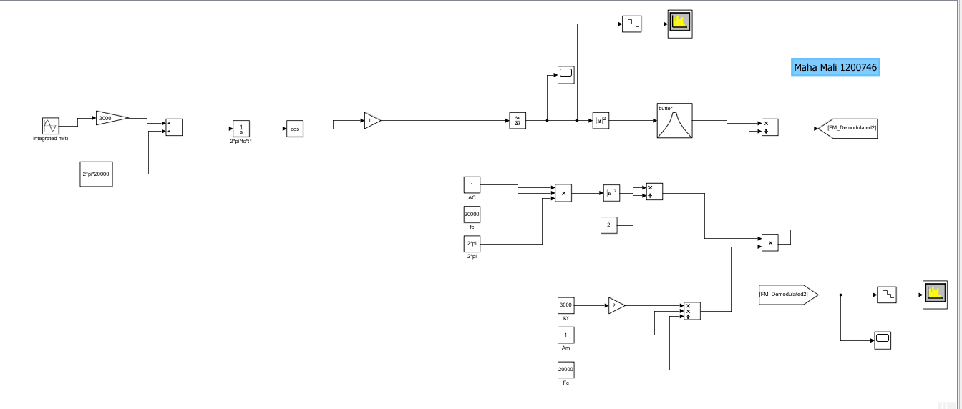

Figure 16::FM Demodulation by using the envelop detector Block Diagram

### In Time Domine

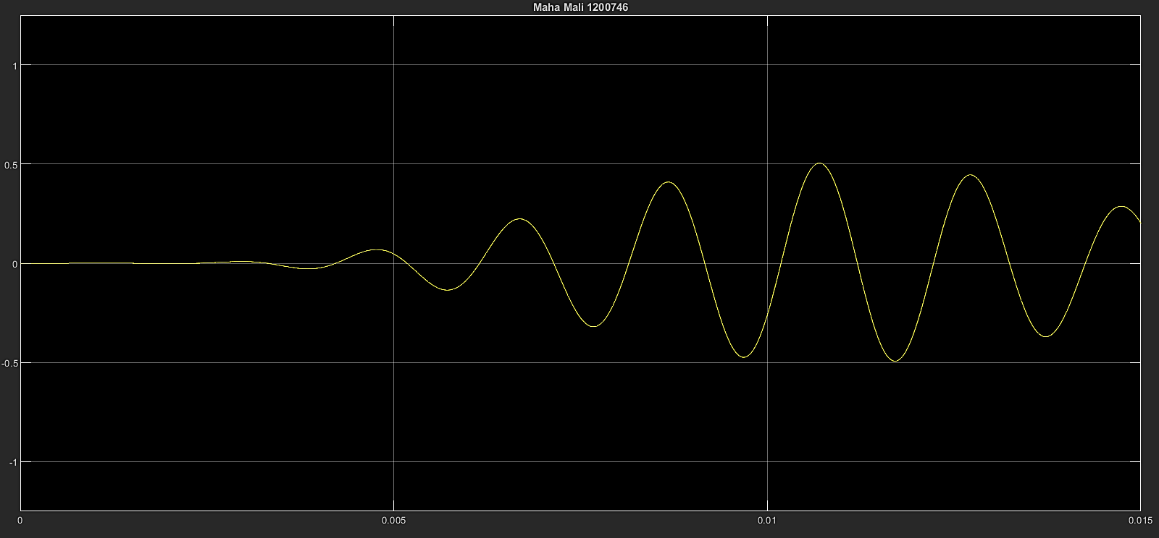

Figure 17: Demodulated signal in time domine

### In frequency Domine

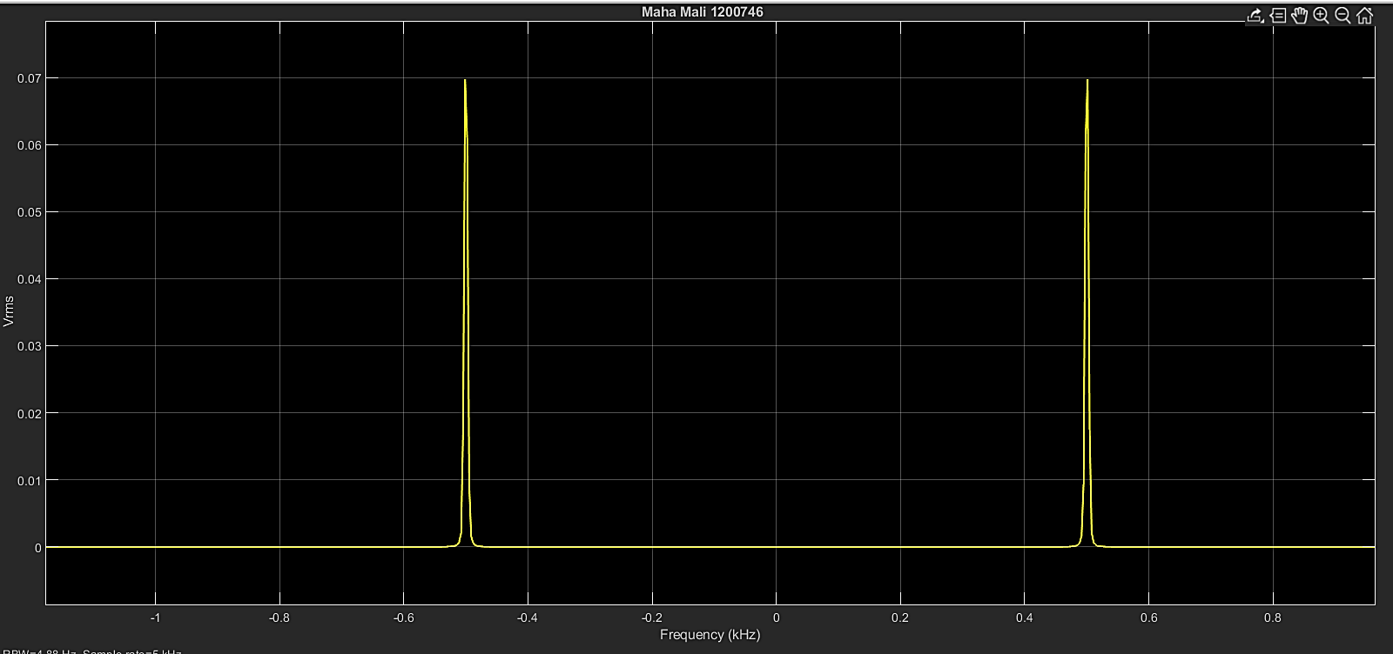

Figure 18: Demodulated signal in time domine

The figure show that the demodulated signal has the same frequency of message signal which is 500 Hz.